INTRODUCTION

Title of our project is “Hotel Management System”. We have tried to show how the data/information in hotels is managed. This is just an overview of management in hotels. It manages and maintains the records of customers, rooms, employees and drivers in the hotel. The project is aimed to maintain the day-to-day state of admission /vacation of Residents, List of employees, room details etc. Main objective of this project is to provide a solution for hotels to manage most their work using computerized processes.This software application will help admin to handle customer information, room allocation details, Payment details etc.The rooms have different categories like single bed, double bed etc. so their charges and records will be maintained accordingly.This software has been made in a user friendly interface, so that anyone can add, delete, update the entries and handle all the transactions easily. As a security I have provided Admin username and Password.

The project, Hotel Management System is a desktop-based application that allows the hotel manager to handle all hotel activities online. Interactive GUI and the ability to manage various rooms, employees, drivers and customers make this system very flexible and convenient. This application gives managers the power and flexibility to manage the entire system from a single online system. Hotel management project provides room booking, staff management and other necessary hotel management features. The system allows the manager to post available rooms in the system.

AIMS & OBJECTIVES

**Aim of the Project :**

The aim of the Hotel Management System is to develop a project which maintains booking of rooms, providing drivers, etc. It is a windows based application to be implemented in Java

**Main Objectives :**

Main objective of this project is to provide a solution for hotels to manage most their work using computerized processes. This software application will help admin to handle customer information, room allocation details, Payment details etc.

* Keeping records of admission of customers.
* Facilities provided by hotels are fully utilized in an effective and efficient manner.

ADMINISTRATIVE MODULES

There are 2 modules I have included in this project:

1. Admin: Admin can add a new room, a new employee and a new driver.

2. Receptionist : Receptionist can add a new customer and allocate rooms, can check all room details, customers details, employee details, search for a particular room etc.

SOFTWARE & HARDWARE

REQUIREMENTS

1.Software Requirements :

* Operating System – Windows 11 is used as the operating system as it is stable, easy to use and supports more features.
* Database – MYSQL is used as database as it more easy to understand and maintain and retrieve records by simple queries which are in English language , making them easy to understand and easy to write .
* MYSQL Workbench – MYSQL Workbench is an software which provides an interface to run and execute MYSQL queries.
* NetBeans IDE – for writing code & executing them
* Language – JAVA
* Development tools – JDK 17.07 ,its an LTS(Long Term Support) version of Java Development Kit

2.Hardware Requirements :

* Processor – Intel core i3 10th generation processor , because its fast and highly reliable processor.
* RAM – RAM 8GB

FEASIBILITY STUDY

# Technical feasibility :

Ascertains that the technology chosen for software development has a large number of users so that they can be consulted when problems arise or improvements are required.

# Economical feasibility :

Cost of hardware, software, development team, and training. Feasible only if tangible and intangible benefits outweigh the cost. The cost for proposed online shopping system is outweighing the cost and efforts involved

# Operational feasibility :

Analyze whether users will adapt to a new software .Determines whether the organization is satisfied by the alternative solutions proposed by the software development team

FUTURE ENHANCEMENT

The world is changing rapidly and so is the meaning of the Hotel Management System. Today hotel management is not only confined to hotels but has gone deep into tourism, catering, clubs, etc making it a very paying and an exciting career option. With the rapid growth of the hotel industry pushed forward by foreign and domestic tourism and business travels, the demand for well trained and quality personnel too has gone up high. India is one of the preferred tourist and travel destinations. Approx 4.4 million tourists visit our country every year. The growth of 20% has been recorded in the tourist and hospitality industry over a few years and more growth is expected in coming years. At present, there are about 200 millions of jobs available in the industry, out of which 20% of the job opportunities are in India. The Hotel Management System has a lot of enhancement options. In future more features may be added category-wise. It may try to analyze the user behaviour and preferences and accordingly suggest. All concepts can be applied to make the Hotel Management System more efficient.

DATABASE & TABLES

Database - hotelmanagementsystem

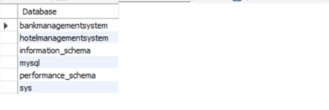

Tables

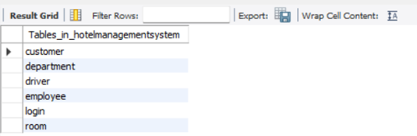

1.login

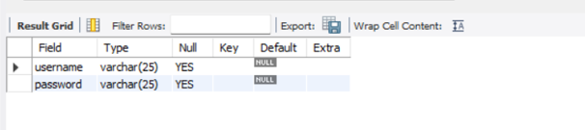

2.employee

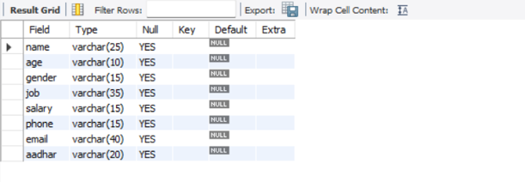

3.department

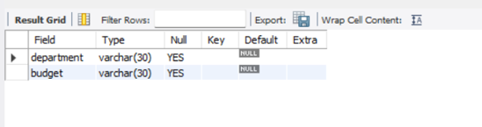

4.driver

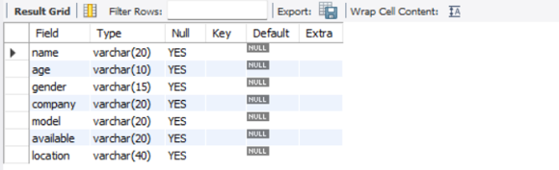

5.customer

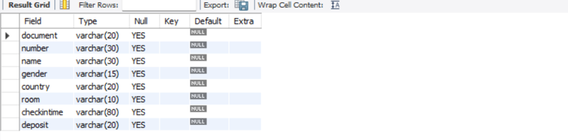

6.room

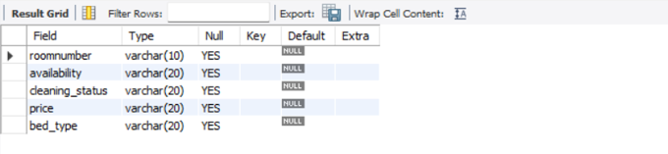

PROJECT SLIDES

1.HotelManagementSystem.java

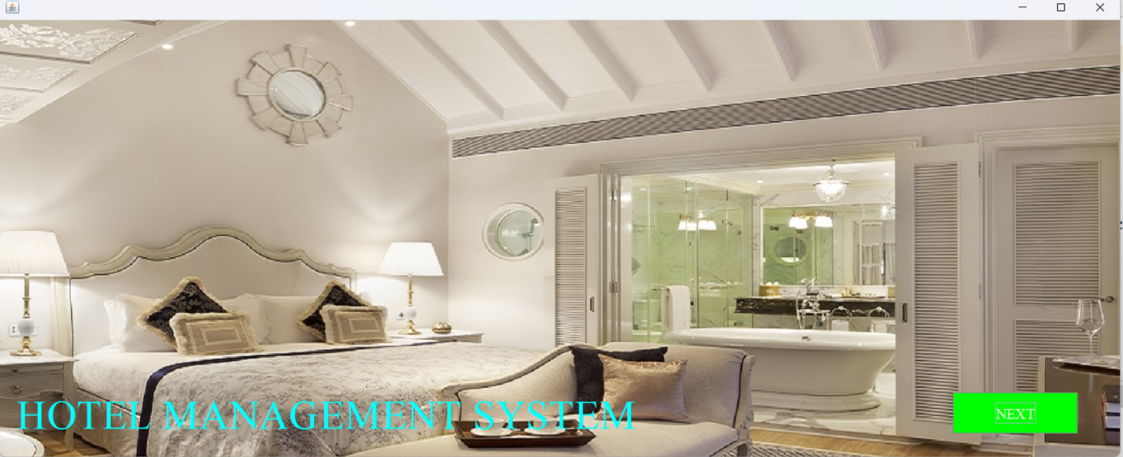

2.login.java

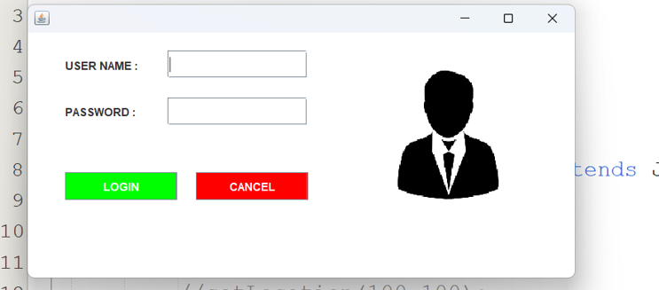

3.Dashboard.java

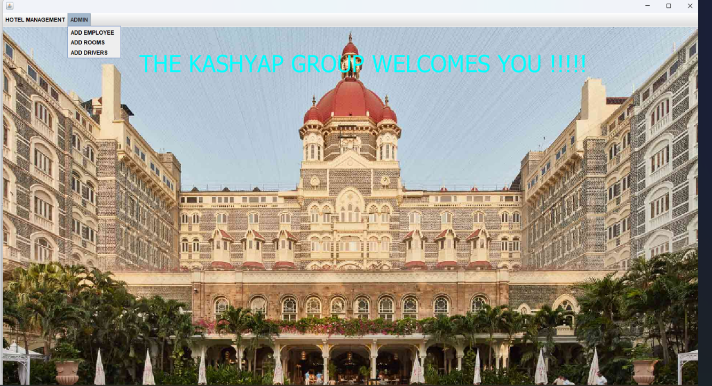

4.AddEmployee.java

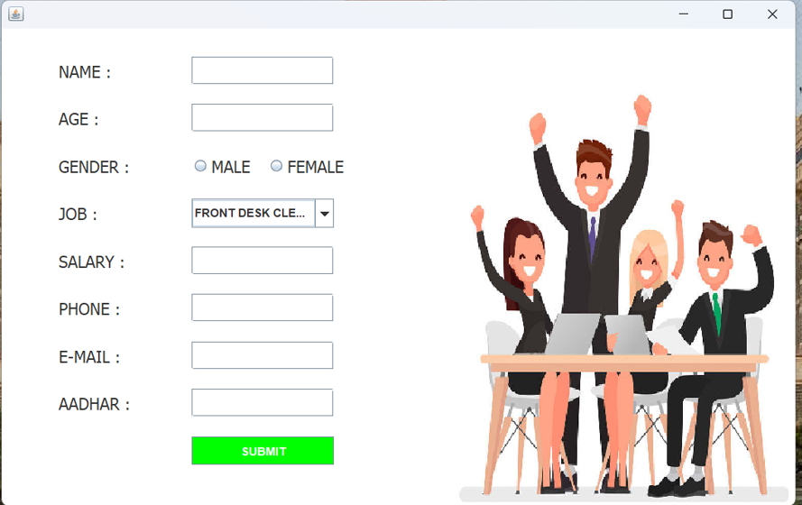

5.AddRoom.java

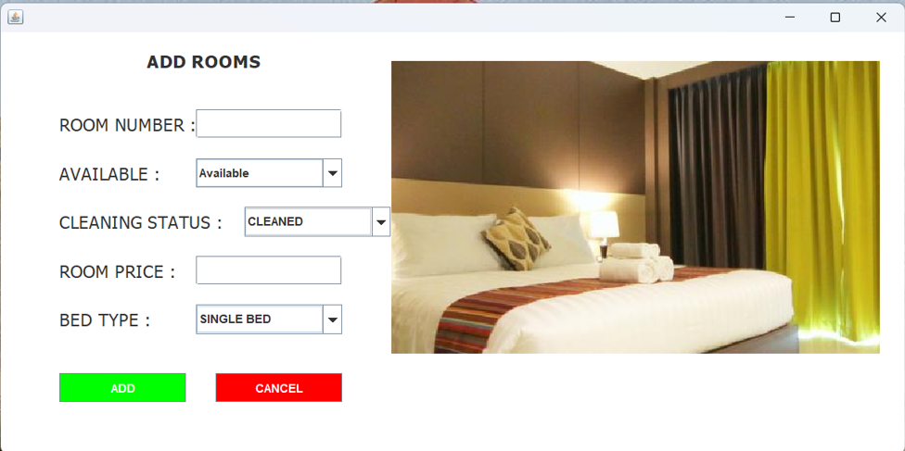

6.AddDriver.java

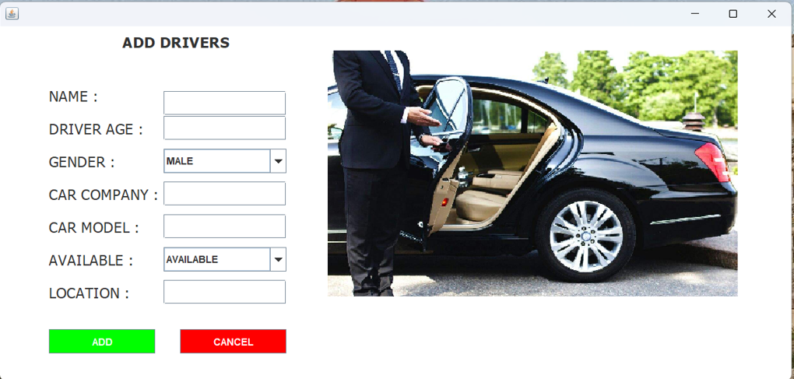

7.Reception.java

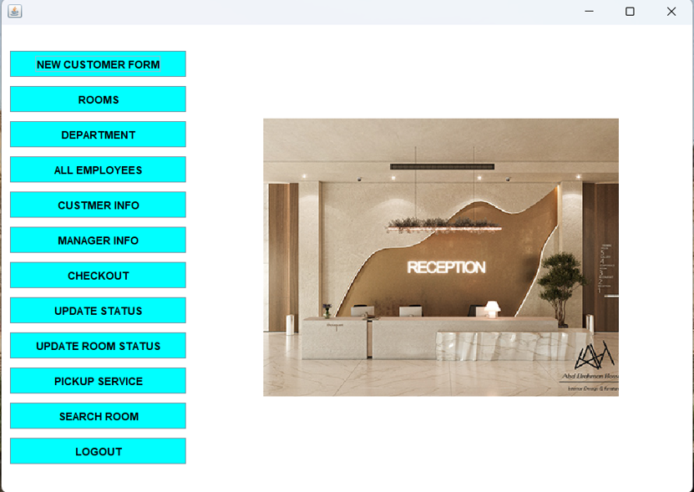

8.AddCustomer.java

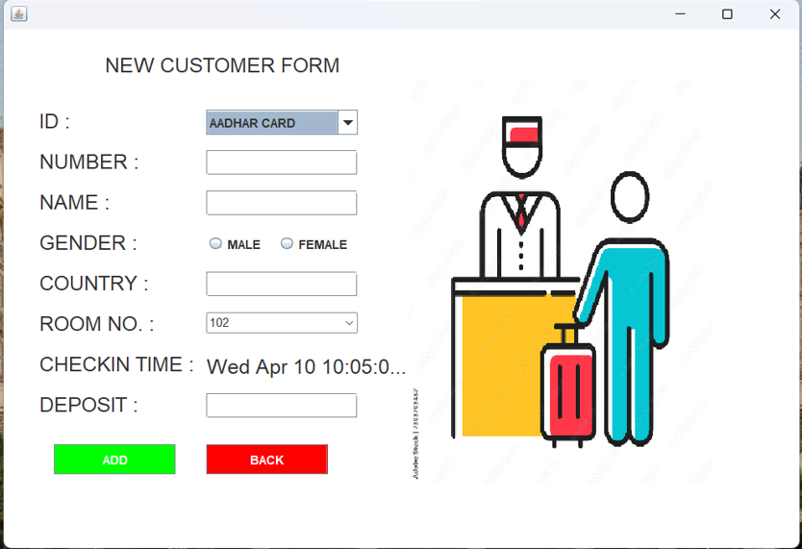

9.Room.java

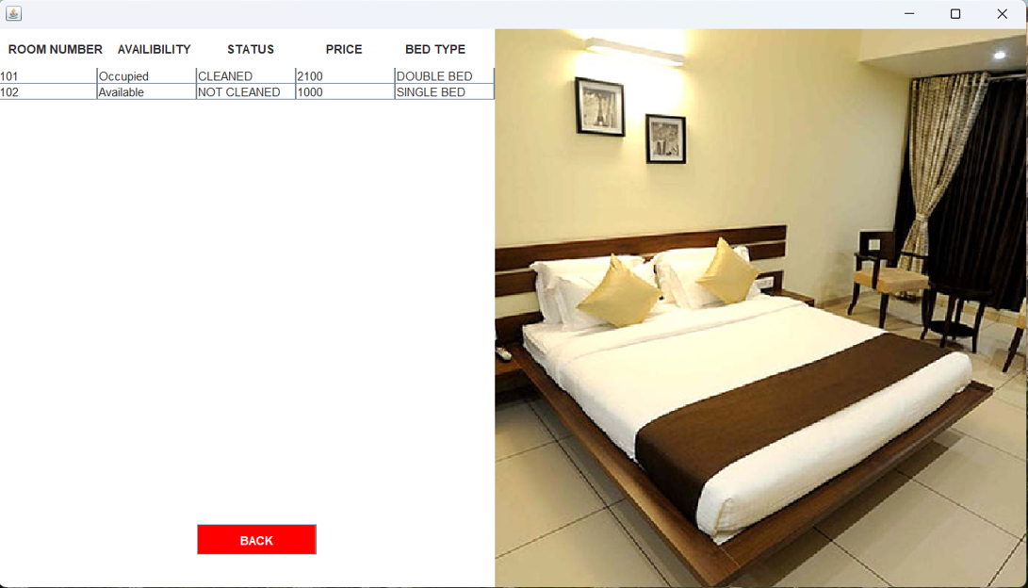

10.Department.java

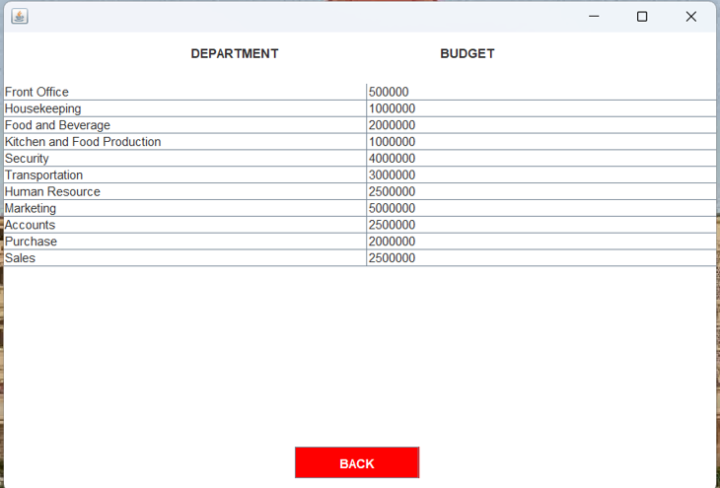

11.EmployeeInfo.java

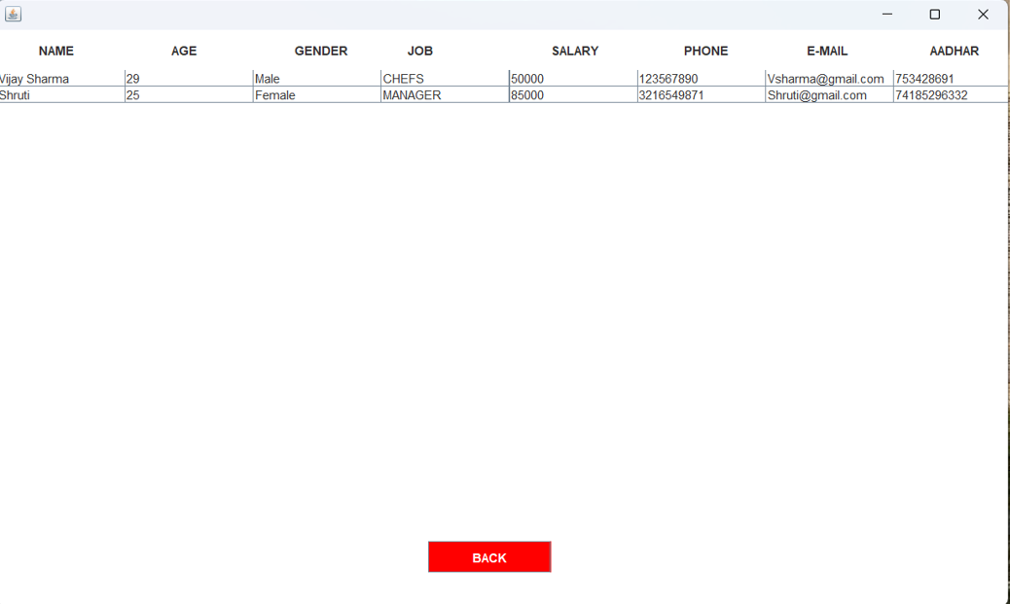

12.CustomerInfo.java

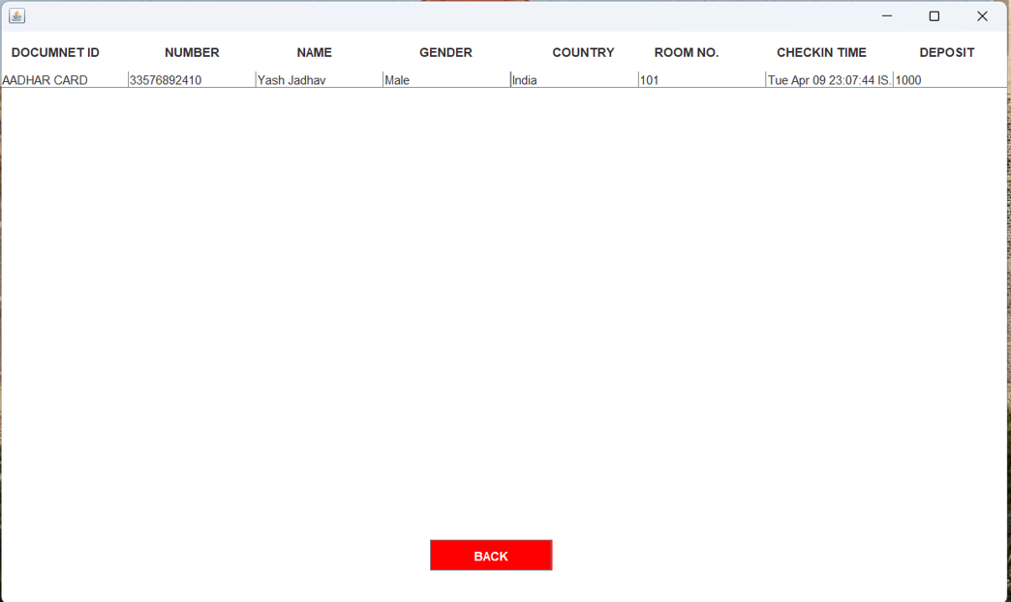

13.ManagerInfo.java

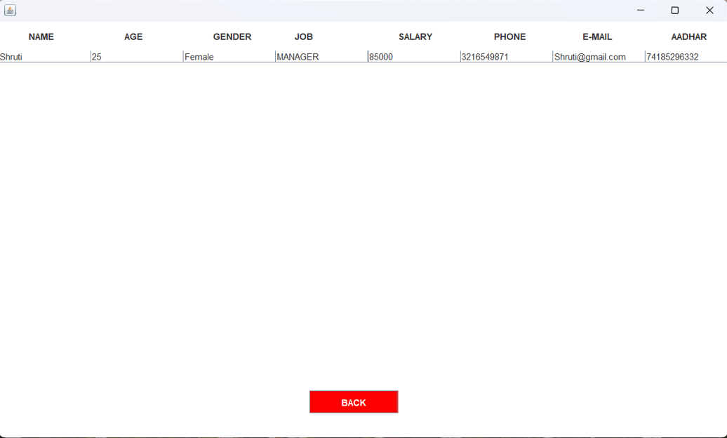

14.SearchRoom.java

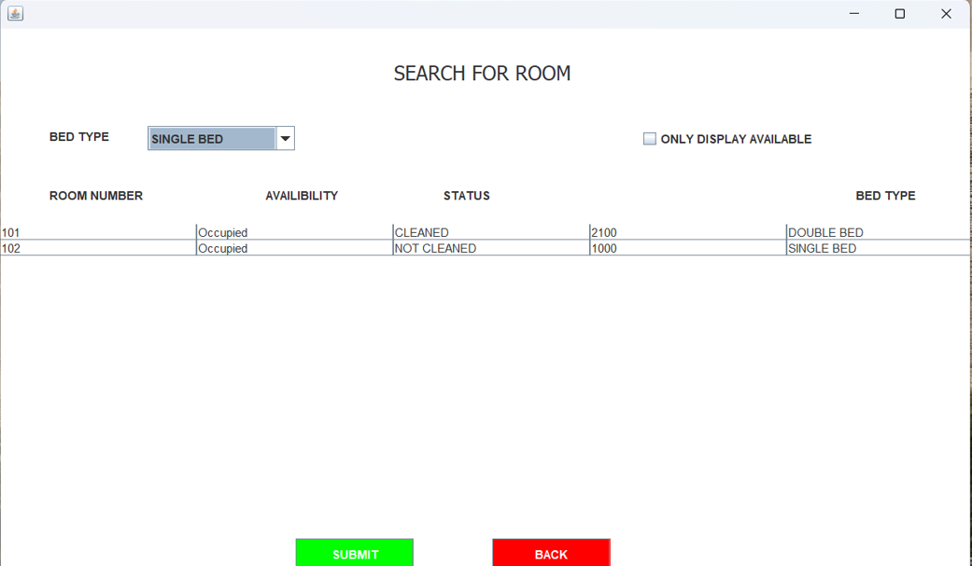

15.UpdateCheck.java

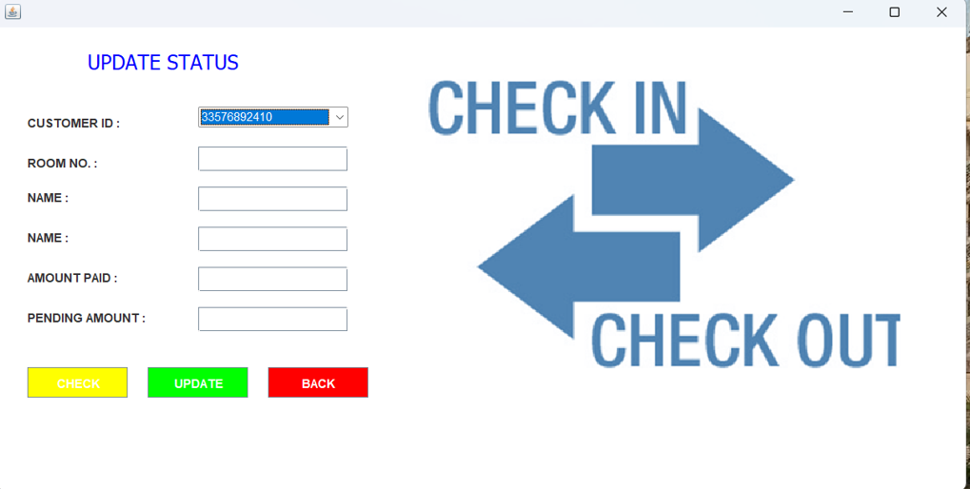

16.CheckOut.java

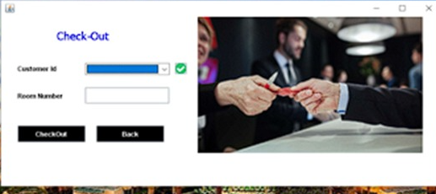

DIAGRAMS

# 1.USECASE DIAGRAM :

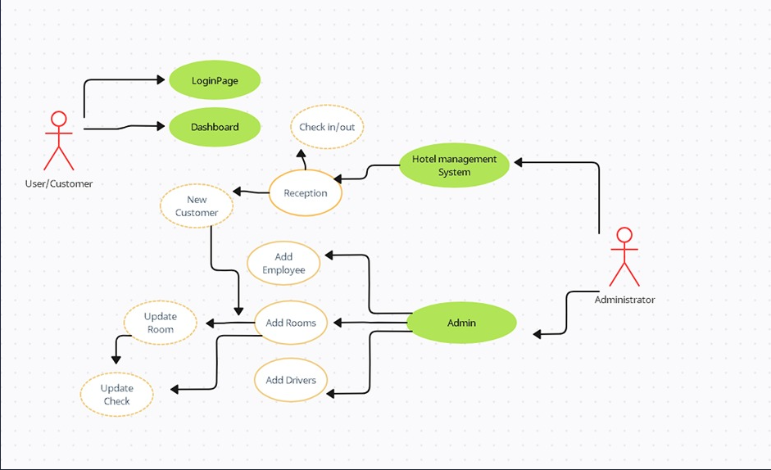

# 2.CLASS DIAGRAM :

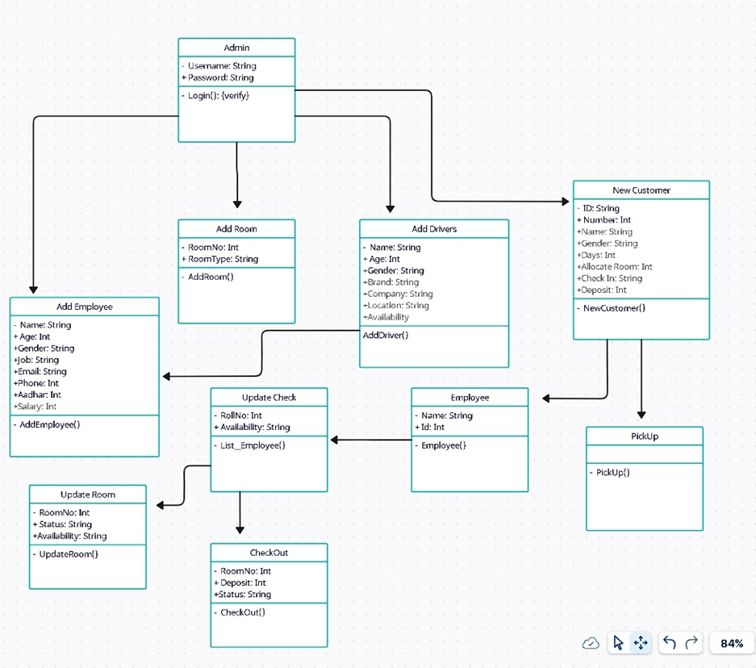

# 3.FLOW-CHART DIAGRAM :

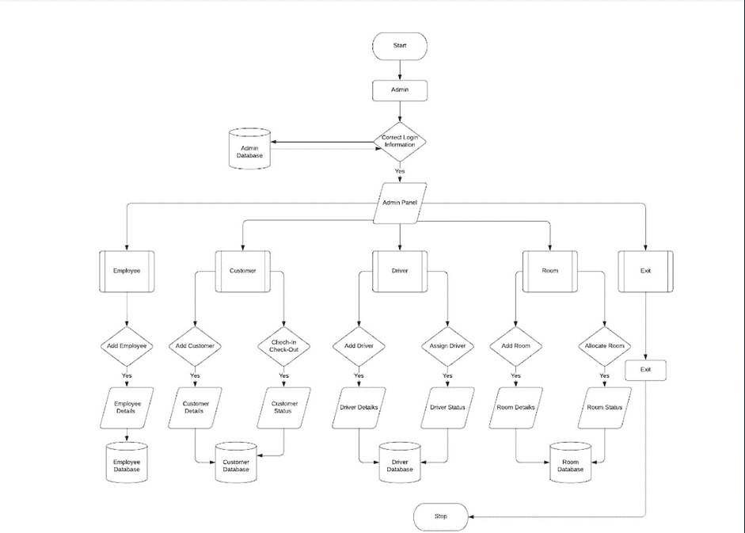

# 5.ER DIAGRAM :

# 

CONCLUSION

In this project I have tried my best to make user friendly software. This software can be handled by any person who has little bit of idea of computers. In this software I have tried to meet most of the requirements of the present hotel management system including maintaining details of customers, rooms, employees and drivers. I also keep provision to update the details of customers, rooms and employees. In my effort I have tried to make my software all the more user friendly but there may some features which I would like to include in my continuous attempts.